CS-340
Professor Morris
Zeb Hawthorne
December 13, 2024

README: CS-340 Dashboard Project
This project is a web dashboard created for tracking animal rescue data using the Dash framework. The dashboard displays a table of animal rescue information and shows a map with a marker for each selected animal's location. You can also use radio buttons to filter rescue types.
The goal of this project was to build an interactive dashboard that displays data and a map side-by-side.

Project Functionality

Key Features:
- Display Data Table:
The app shows a table of rescue data where each row represents an animal. The table supports sorting and filtering.
- Interactive Map:
When you select a row in the table, the map updates to show a marker on that animal's rescue location.
- Filter Options:
There are radio buttons to filter the data by rescue type (Water Rescue, Mountain Rescue, Disaster Tracking, etc.).

Proof of Functionality:
Below is a screenshot showing the dashboard in action:
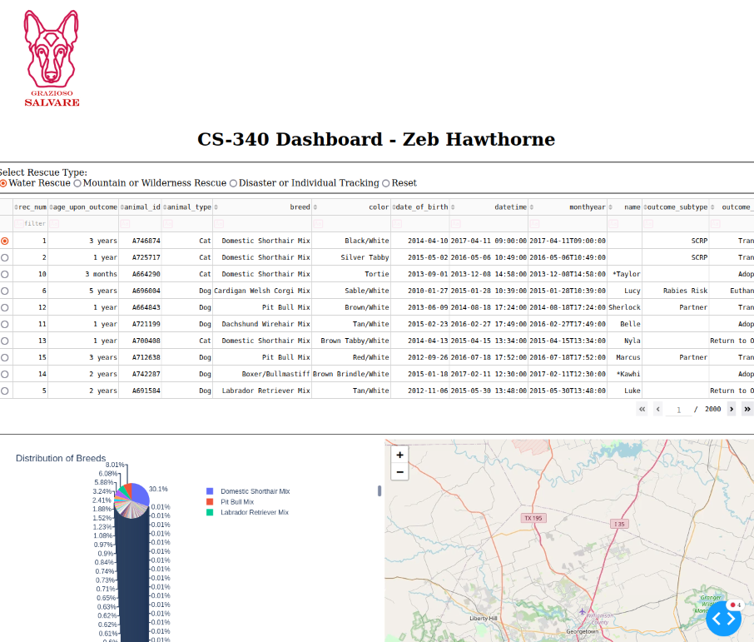

Tools Used
- Dash Framework
- Why: Dash makes it easy to create web apps with Python. It combines Python, HTML, and JavaScript to build dashboards quickly.
- Website: Dash Documentation
- MongoDB
- Why: MongoDB is a NoSQL database that stores data in a flexible format (documents). It's easy to work with in Python, especially when handling dynamic data.
- Features:
- Stores data in JSON-like documents.
- Scales well with large amounts of data.
- Works smoothly with Python libraries like pymongo.
- Other Tools
- Pandas: Used for data manipulation.
- Website: Pandas Documentation
- Dash Leaflet: Used for displaying the interactive map.
- Website: Dash Leaflet Documentation
- Base64 Encoding: For displaying the logo image.

Challenges and Solutions
- Loading the Image
- Challenge: The logo image wasn’t displaying.
- Solution: Made sure file was in the correct directory.

- Connecting to MongoDB
- Challenge: Had trouble connecting to the MongoDB database.
- Solution: Made sure MongoDB was running and used the correct connection string.

